|  |
| --- |
| Esri  9-11-2018 |

|  |
| --- |
| Esri |
| Spatiotemporal Big Data Store |
| Map Service Specification |

Spatiotemporal Big Data Store: Map Service Specification

Overview 2

Map Service Specification 2

Aggregation Rendering 2

Feature Threshold 3

Aggregation Style 5

Aggregation Spatial Reference 6

Bin Rendering Style 6

Aggregation Method 9

Statistics Field 9

Statistics Type 9

Show Labels 10

Label Style 10

Label Format 10

Min Bin Size (pixels) 10

LOD Offset 11

Bin Renderer 12

Normalize by Bin Area 14

Feature Rendering 15

Feature Rendering for Points and Multipoints 15

Feature Rendering for Polygons 20

Feature Rendering for Polylines 21

# Overview

This document outlines the specification for the spatiotemporal big data store map service. You can access map service specification by following two methods from ArcGIS GeoEvent Manager (e.g. https://<your-server>.domain.com:6143/geoevent/manager):

1. When you create a new data source in GeoEvent Manager:
   1. Navigate to **Services** 🡪 **Outputs**
   2. Click **Add Output**
   3. Select the **Add a Feature to a Spatiotemporal Big Data Store** output
   4. Click **Create Data Source**
   5. Access map service properties under ***Aggregation Rendering*** and ***Feature Rendering***
2. When you edit an existing spatiotemporal big data store map service in GeoEvent Manager:
   1. Navigate to **Site** 🡪 **Spatiotemporal Big Data Stores**
   2. Locate the existing spatiotemporal big data store map service and click cid:image001.png@01D44464.E1C01FB0 to edit the map service
   3. Access map service properties under ***Aggregation Rendering*** and ***Feature Rendering***

# Map Service Specification

Hosted spatiotemporal big data store map services can be rendered aggregated using a chosen aggregation style or by rendering the discrete features. This document will cover both the options available for aggregation rendering as well as those for discrete (aka “raw”) feature rendering.

## Aggregation Rendering

Hosted spatiotemporal big data store map services can be rendered using different aggregation styles. The aggregation styles and associated properties for the supporting map services are highlighted below.

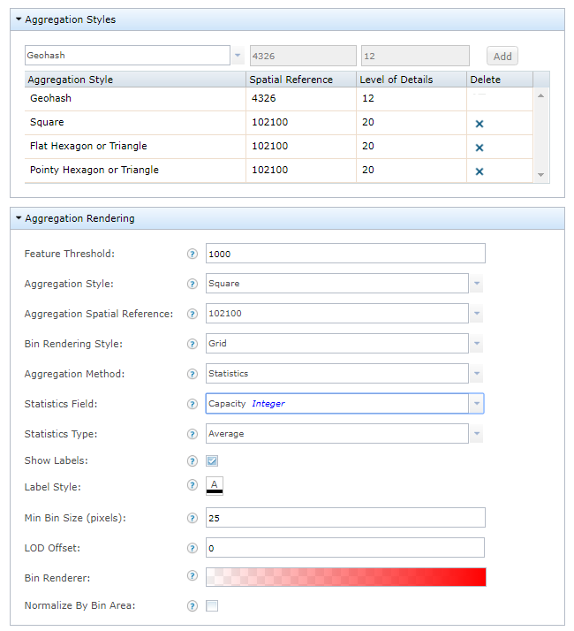

### Feature Threshold

The feature threshold is used to determine when to switch the rendering style of the map service between an aggregation style and discrete features. When the number of features to be rendered in the current map extent is more than the feature threshold specified, the features will be rendered using an aggregation style; if equal or less, the features will be rendered using raw discrete features. With the feature threshold set to the default value of 0, the features will render aggregated using the chosen aggregation style at all scales.

**EXAMPLE:** With a feature threshold value set to 20, when the map is zoomed out and more than 20 features in the current map extent need to be rendered, the features will be aggregated into bins and will be rendered using the defined aggregation style as illustrated below.

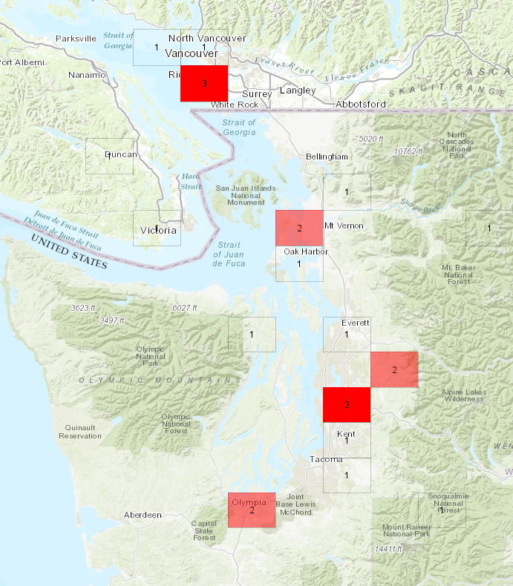

When you zoom in on the map to display equal or less than 20 features in current map extent, the features will be rendered using the defined raw discrete feature rendering style as illustrated below.

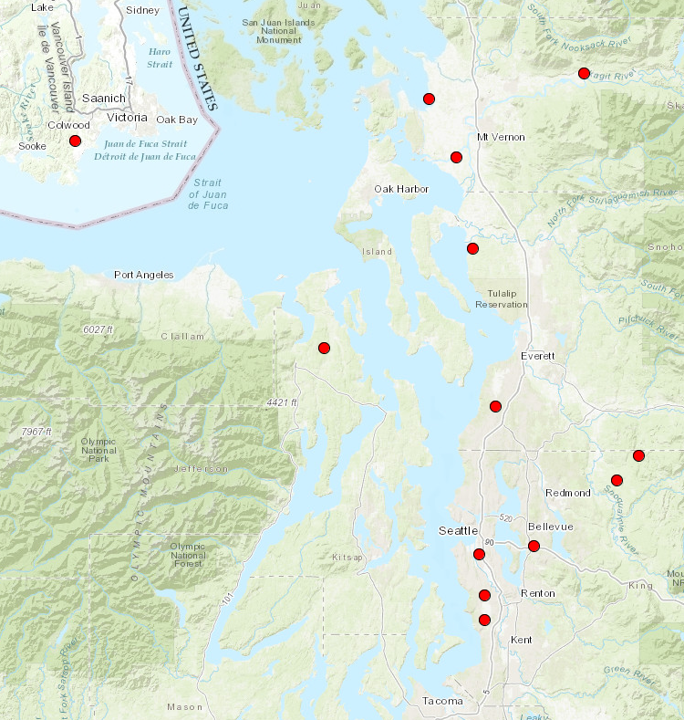

### Aggregation Style

The aggregation style the aggregation renderer will use to display the aggregated features.

|  |  |
| --- | --- |
| **Geohash** | **Square** |
|  |  |
| **Flat Hexagon** | **Pointy Hexagon** |
|  |  |

|  |  |
| --- | --- |
| **Flat Triangle** | **Pointy Triangle** |
|  |  |

### Aggregation Spatial Reference

The spatial reference well-known ID (WKID) or well-known text (WKT) to use for aggregation rendering. This property is relevant and enabled only when the Geohash aggregation style is NOT selected. The Geohash aggregation style is defined to only use WKID=4326 (using predefined 12 level of details), as defined by the Geohash specification.

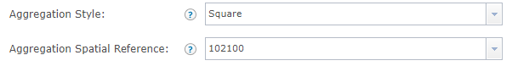

### Bin Rendering Style

The aggregation bin-rendering-style is used to determine how the aggregated bins are rendered.

Using the *Grid* bin-rendering-style, the bins will be rendered as polygon outlines with a fill to form a ‘grid’ along the aggregation style axes.

Using the *Oval* bin-rendering-style, the bins will be rendered as ellipses with diameters that will encapsulate an oval inside the bin’s shape, centered around the bin’s center point, following the aggregation style axes.

|  |  |
| --- | --- |
| **Geohash** | |
| Grid | Oval |

|  |  |
| --- | --- |
| **Square** | |
| Grid | Oval |
| **Flat Hexagon** | |
| Grid | Oval |
| **Pointy Hexagon** | |
| Grid | Oval |
| **Flat Triangle** | |
| Grid | Oval |
| **Pointy Triangle** | |
| Grid | Oval |

When the *Oval* bin rendering style is selected, the *Size (in percentage)* parameter is enabled in the *Bin Renderer* property for calculating each oval bin size based on its bin value. The oval bin size for each bin is determined by using its bin value as a weight to interpolate from the min to the max size values.

**EXAMPLE:** As illustrated below, the oval bin sizes are interpolated from 30% for the min value to 100% for the max value. Bins with the min bin value use 30% of the oval size, bins with the max bin value use 100% of the oval size, and the other bins use its bin values as a weight to interpolate from the min to the max values. As a result, bins with values of 1, 2, 3 are rendered with increasing sizes. When the min and the max size values are set to the same value, oval bin sizes are not differentiated by bin values and result in the same oval bin size for all bins. Also see the *Range* setting in the *Bin Renderer* property.

|  |  |
| --- | --- |
| **Oval – 30%/100%** |  |
|  |  |
| **Oval – Size 100%/100%** |  |
|  |  |

### Aggregation Method

The method for calculating the aggregated bin values that appear in each bin. Choose *Count* to display feature counts in each bin. Choose *Statistics* to calculate statistics of all features in each bin based on the *Statistics Field* and the *Statistics Type* parameters below.

Values: Count | Statistics

**EXAMPLE**: The aggregation bin value could be the number of sensors in a bin or the average temperature reported from all sensors in a bin.

### Statistics Field

The statistics field to use for calculating the aggregated statistics value.

### Statistics Type

The statistics type to use for calculating the aggregated statistics value.

Values: Average | Maximum | Minimum | Standard Deviation | Sum | Variance | Count Distinct | Count

|  |
| --- |
| **Counts** |
|  |
| **Statistics** |
|  |

### Show Labels

The bin labels are displayed in each bin and represent the bin value in each bin. When *Show Labels* is checked, the count of features or the statistic value for each bin will be rendered around the bin’s center. When unchecked, no labels will appear inside the bins.

|  |  |
| --- | --- |
| **Checked** | **Unchecked** |
|  |  |

### Label Style

The style of the bin labels – PLAIN, BOLD, ITALIC, BOLD ITALIC.

### Label Format

The label’s text value format pattern based on the Java Decimal Format specification. For more information see:

* <https://docs.oracle.com/javase/tutorial/i18n/format/decimalFormat.html>

You can also add “KMB” or “kMG” to format big number values with “K/k” for thousands (aka “kilo”), “M” for millions (aka “mega”), and “B/G” for billions (aka “giga”).

**EXAMPLE:** “###.##kMG” format will render “789.12M” instead of “789,123,456”.

For more information see:

* <https://en.wikipedia.org/wiki/Metric_prefix>
* <https://physics.nist.gov/cuu/Units/prefixes.html>

### Min Bin Size (pixels)

The *Min Bin Size (pixels)* and *LOD Offset* parameters work together when aggregating features. The goal is to render the most detailed level of detail (LOD) possible while making the bin size (width) equal to or larger than the min bin size specified. The aggregation renderer then applies the LOD offset to determine the final LOD to use for rendering. The default value is: 25.

**EXAMPLE:** With the Min Bin Size=150 pixels and LOD Offset=2, if rendering using LOD=4, the number of pixels per bin is 200. If the LOD=5, the number of pixels per bin is 100. In this case, to satisfy the min bin size of 150, the render uses LOD of 4 instead of LOD of 5. Because the LOD offset value is 2, it then applies 2 on top of LOD 4 and eventually renders using LOD=4+2=6. If the LOD offset value is set to -2, it will render using LOD=4-2=2.

|  |
| --- |
| **Min Bin Size (pixels) with LOD offset=0** |
| 25 |
| 10 |
| 50 |

### LOD Offset

The LOD offset to apply to in addition to the LOD determined by the *Min Bin Size* parameter above.

**EXAMPLE:** If based on the min bin size, the map service renders using LOD=5. If the LOD Offset=3 it eventually renders using LOD=5+3=8. For the same case, if LOD Offset=-3, it renders using LOD=5-3=2.

|  |
| --- |
| **LOD Offset** |
| 0 |
| 1 |
| -1 |

### Bin Renderer

The *Fill Color*, *Outline Color*, and *Outline Size* for each bin (as well as the oval bin size when oval is selected for the bin rendering style), use the bin value as a weight to interpolate from the min to the max of the *Range* values specified. A bin with a bin value equal to the min of the range value uses the min of the fill color, outline color, and outline size specified. In a bin with the bin value equal to the max of the range value will use the max of the fill color, outline color and outline size specified. If a bin value falls between the min and the max range value, the renderer uses its bin value as a weight to interpolate from the min to the max of range values to determine the Fill Color, Outline Color and Outline Size for that bin. If a bin value falls outside of the range values, the aggregation renderer will use the min value if its bin value is smaller than the min range value and use the max value if its bin value is greater than the max range value. If leaving min and max range values blank, the aggregation renderer will calculate the min and max bin values from the current map extent and use them as the min and max for the range values.

**EXAMPLE:** As illustrated below, the range is set to min=100 and max=1000 and corresponding fill color for the min is transparent red R=255, A=0% (A is the transparency) and the max is opaque red R=255 and A=100%. From the final rendering, you can observe the following:

For bin values less than 100: the min fill color of R=255 and A=0% is used.

For bin values greater than 1000: the max fill color of R=255 and A=100% is used.

For a bin value between 100 and 1000, its bin value as a weight is used to interpolate from A=0% to A=100% to determine the transparency for that bin.

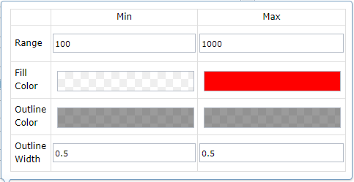

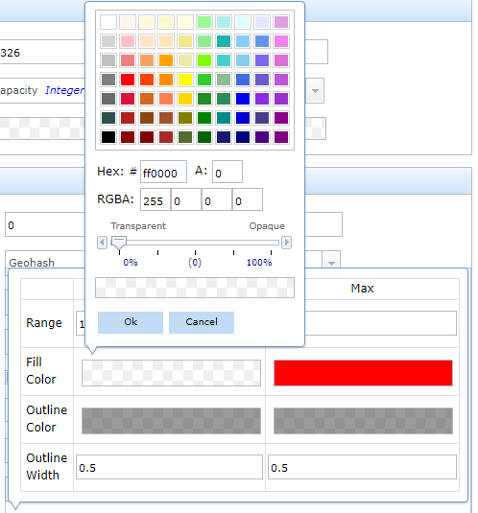

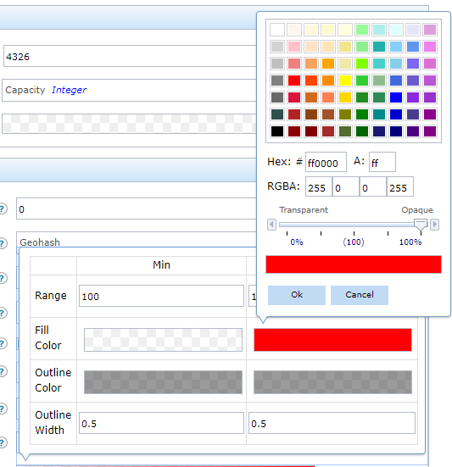

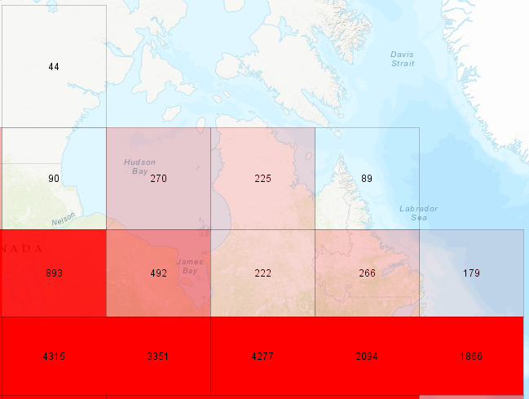

### Normalize by Bin Area

Bins that appear the same size on a map can cover a different geographically sized area. For example, a bin at the equator covers a larger geographic area than a bin at the north pole even if the two bins are the same size in a map. If their bin values are the same, the bin at the equator has less density compared with the bin at the north pole. When *Normalize by Bin Area* is checked, the rendering is normalized. As an example, a bin at the equator will have a lighter color, while the bin at the north pole will have a darker color, assuming the fill color the max value uses is a darker color than the min value. When *Normalize by Bin Area* is unchecked, the renderer treats all bins as the same sized geographic area.

## Feature Rendering

Spatiotemporal big data store map services can render using the aggregation style or the discrete feature style based on *Feature Threshold* parameter’s value. Refer to the following parameters to specify how to render discrete features.

### Feature Rendering for Points and Multipoints

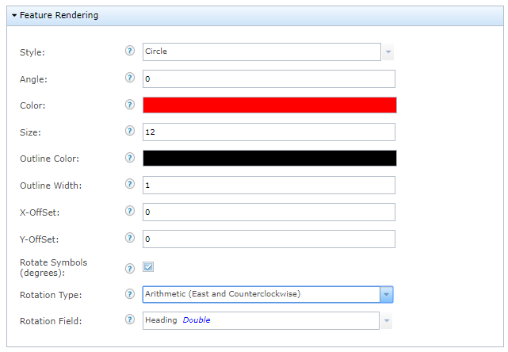

**Style**

The simple marker symbol style to render discrete features.

|  |  |
| --- | --- |
| **Circle** | **Cross** |
|  |  |

|  |  |
| --- | --- |
| **Diamond** | **Square** |
|  |  |
| **X** | **Triangle** |
|  |  |
| **Pointer** |  |
|  |  |

*Note: If updating the feature service to render Triangle and Pointer, it still renders using circle; if updating from map service, it renders Triangle and Pointer for discrete features. This is a known issue.*

**Angle**

The value in degrees (0° - 360°) the simple marker symbols will be rotated for all features. The rotation starts in the east in a counter-clockwise direction, where east is 0°.

|  |  |
| --- | --- |
| **Angle examples** |  |
| 0° | 45° |

**Color**

The color of the simple marker symbol used to represent discrete features. The default is: Red

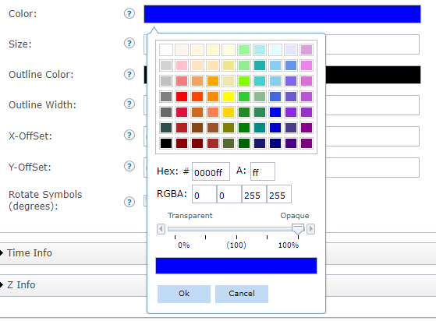

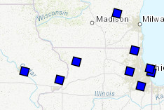

**Size**

The size of the simple marker symbol used to represent discrete features. The default size is: 12.

|  |  |
| --- | --- |
| **Size examples** |  |
| 12 | 24 |

**Outline Color**

The outline color of the simple marker symbol used to represent discrete features. The default is: Black

**Outline Size**

The outline size for the simple marker symbol used to represent discrete features. The default is: 1

|  |  |
| --- | --- |
| **Outline Color/Size Examples** |  |
| Black/1 | Pink/3 |

**X-Offset (pixels)**

The value, in pixels, to offset the discrete features on the x-axis.

**Y-Offset (pixels)**

The value, in pixels, to offset the discrete features on the y-axis.

|  |  |
| --- | --- |
| **Offset Examples** |  |
| (0,0) | (10,10) (move to upper right) |

**Rotate Symbols (degrees)**

The value to rotate the simple marker symbols based on a rotation type and field value in degrees (0°-360°).

**Rotate Type**

The rotation type used to rotate the simple marker symbols. The rotation type chosen controls the origin and direction of rotation. If the rotation type is defined as *arithmetic*, the symbol is rotated from east in a counter-clockwise direction where east is the 0° axis. If the rotation type is defined as *geographic*, the symbol is rotated from north in a clockwise direction where north is the 0° axis.

The rotation type:

Arithmetic – 0° is east and advances counter-clockwise

Geographic – 0° is north and advances clockwise

**Rotate Field**

The field containing the value in degrees (0° - 360°) to rotate the discrete features.

|  |  |
| --- | --- |
| **Arithmetic** | |
|  | |
| Not rotated | Rotated |
| **Geographic** | |
|  | |
| Not rotated | Rotated |
|  |  |

### Feature Rendering for Polygons

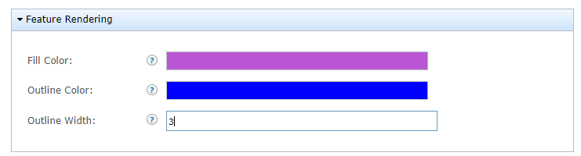

**Fill Color**

The fill color of the polygon.

**Outline Color**

The outline color of the polygon.

**Outline Size**

The size of the polygon outline.

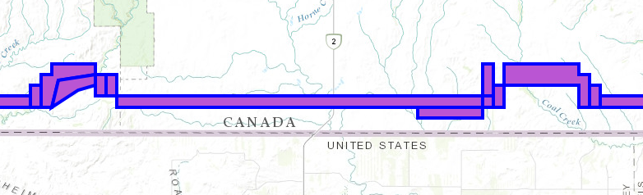

### Feature Rendering forPolylines

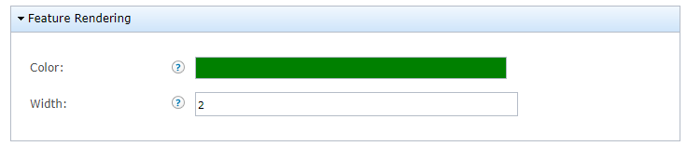

**Color**

The color of the polyline.

**Size**

The size of the polyline.

